Things to incorporate into the documentation:

Example in conversation 1

* Completely unrelated messages are correctly answered “I could not find any relevant information in the data specification for your message. “
* Unrelated message but there are words that could be mapped: LLM still maps it. The work flow continues as if the user has asked about the data specification.
  + This is of course unintended. During development, I was too focused on fine tuning for the case when user asks about something relevant.
  + I forgot about fine-tuning for the negative case.
* Ambiguous or complex queries that could map to multiple concepts. How does the application handle this? Does it present options to the user?
  + Short answer: I ask the LLM for exactly one item from the data specification. The same word or phrase will not map to multiple items.
  + Longer anser: depends on the LLM used. Smaller LLMs tend to not follow the given rules strictly so even though I ask for exactly 1 item for each word or phrase, it will return multiple items. In this case, I will show the user all of them.
  + Future work: map concepts to more items. Show the user all of them and ask the user to choose.

Explain the case when there are seemingly multiple of the same concepts. Multiple vehicles, multiple fyzicka osoba, …

Point out that each item is added to the substructure only once. Therefore I don’t support more complex queries.

- Do dokumentace napsat omezení, že přidávám každý item (třídu nebo propertu) jen jednou. Takže některé typy dotazů nejsem schopen vyřešit.

- Více tříd má stejný label, ale různé IRI.

Tady asi sloučit v části suggestions. Ale v části substructure to nechat.

- Vyfiltrovat seznam suggested properties, abych nabízel každý unique property jen jednou.

Pokud mám domain i range nějaké property, tak v tom seznamu je dvakrát, jednou že expanduje domain a podruhé že expanduje range.

- Rozmyslet si, jestli nemůžu podpořit přidání třídy vícekrát. Protože třída může mít property vedoucí na sebe (orgán veřejné moci -> má nadřízený orgán -> orgán veřejné moci)

V tuto chvíli moje sémantika znamená, že chci orgán veřejné moci, který má sebe jako nadřízený orgán veřejné moci.

Myslím, že bych to mohl takto upravit.

To, že některý property se ve feature objeví 2x (jednou pod třídou A, kde A je range a podruhé pod třídou B, kde B je domain), tak nemusí nutně být bug.

- Nechal jsem to tak, protože se mi zdálo docela hezké, že je vidět, že ta properta spojuje ty 2 třídy.

**Expected Project Documentation Structure**

The final documentation should be a self-contained, comprehensive report that serves as both a final deliverable and a reference for future work. It must not simply repeat the proposal and specification but rather report on the *implementation* of those documents.

**1. Abstract**

A brief, high-level summary of the entire project. It should concisely state the problem, the solution, the technologies used, and the key findings.

**2. Introduction**

This section should set the context for the project.

* **Problem Statement:** Reiterate the original problem the project aimed to solve.
* **Project Goals:** Clearly state the project’s objectives as outlined in the proposal and specification.
* **Contribution:** Describe the specific contributions of this work. This is where you would explain what was built, what new knowledge was gained, and how it advances the field.

**3. Literature Review and Background**

While the proposal likely had a basic literature review, the final document should have a more in-depth one, focusing on the specific technologies and methods used.

* **LLMs and Prompt Engineering:** Discuss the evolution of LLMs and the principles of prompt engineering that were applied.
* **Knowledge Graphs and SPARQL:** Explain the role of knowledge graphs and SPARQL in the context of the project.
* **Related Work:** Mention other projects or tools that have attempted similar tasks and explain how this project is different or builds upon their work.

**4. System Design and Architecture**

This section is the core of the document and must be highly detailed. It should go beyond the abstract design presented in the specification.

* **Overall Architecture:** Present the final, as-built architecture, detailing all components and their interactions. Use diagrams to illustrate the flow of data.
* **Module Descriptions:** Dedicate a subsection to each major module (e.g., LLM Connector, Conversation Service, SPARQL Translation Service). For each module, describe its function, inputs, outputs, and the technologies used in its implementation.
* **Data Model:** Detail the database schema used to store conversation history, data specification substructures, and any other relevant data. Explain the rationale behind the design.
* **API Documentation:** Provide a complete and accurate documentation of the RESTful API endpoints, including request and response formats.

**5. Implementation and Technical Details**

This is where the student proves they have delivered on the project.

* **Technology Stack:** List and justify the final set of technologies and frameworks used for the backend and frontend.
* **Code Structure:** Describe the project’s code structure and how it adheres to the modular design.
* **Deployment:** Explain how the application is deployed and configured.

**6. Evaluation and Results**

This is the most critical section for an opponent. It must demonstrate that the project is a success and has met its goals.

* **Performance Metrics:** Present quantitative results. For example:
  + **Translation Success Rate:** What percentage of natural language queries are successfully translated into correct SPARQL queries?
  + **LLM Comparison:** A head-to-head comparison of the performance of different LLMs on a defined set of test cases.
  + **Latency:** The time it takes for the system to generate a SPARQL query and a suggested response.
* **User Study:** If a user study was conducted, report on its findings. Did users find the system intuitive? Did it successfully help them navigate the data specification?
* **Analysis of Results:** Do not just present data. Interpret it. Explain *why* certain LLMs performed better than others, or why certain types of queries failed.

**7. Discussion and Conclusion**

This section should reflect on the project as a whole.

* **Challenges and Solutions:** Describe the major technical challenges encountered during the implementation phase and how they were overcome.
* **Future Work:** Propose logical next steps for the project. This shows an understanding of the project’s limitations and potential for growth.
* **Final Conclusion:** A strong concluding statement summarizing the project’s success and its value.

**Important Points to Emphasize**

* **Evidence, Not Just Claims:** The documentation must provide *evidence* for every claim. For example, if the project is independent of a specific LLM, show the code structure and provide an example of how a new LLM could be integrated.
* **Adherence to Specification:** The documentation must explicitly link the final implementation back to the original project specification. For each major use case or user story from the spec, the documentation should describe how it was implemented and whether it was successfully delivered.
* **Critical Self-Assessment:** A high-quality report will not shy away from the project’s limitations. It should discuss what did not work as expected and what lessons were learned. This demonstrates academic maturity and a deep understanding of the problem space.
* **Reproducibility:** The documentation should include clear instructions on how to set up and run the project from scratch, including all dependencies and configuration details.

Data specification navigator (documentation)

# Abstract

This project addresses the common problem faced by users who are interested in their organization’s data but do not fully grasp the whole domain ontology and the underlying technical structure. The project’s goal is to act as a conversational intermediary, creating a standalone application that allows users to ask questions in plain language. The final implementation successfully guides the user through the data specification and provides users with executable SPARQL queries, but it still has considerable limitations. The full range of SPARQL syntax is not supported in the current implementation. While the solution is a monolithic application, a key aspect is its modular architecture, ensuring future adaptability and independence from any one specific large language models.

# Introduction

This document presents the realization of the project named “Helping users navigate data specifications”.

## Motivation

The project’s motivation is best understood through a common scenario: Tanya needs some specific data from her organization’s database. She must visit her organization’s “database person” and formulate her question: “I would like to see our employees who started working here this year”. This “database person” will then query the database and give Tanya a list of employees. The “database person” could also ask: “Do you want all the employees or only employees from a specific department?”. Tanya will answer the question and the two of them can continue in an iterative manner to refine Tanya’s query. My project directly addresses this bottleneck by creating a standalone application that acts as a digital intermediary.

The developed application allows the same kind of iterative refinement of the user’s query as in the given example, eliminating the need for a human expert (the “database person” in our previous example).

# System design and architecture

The application has a client-server architecture, which comprises of a thin-client frontend and a C# backend.

## Frontend

The user interface (UI) was designed as a thin client to ensure it is lightweight and responsive. It is a single-page application that communicates with the backend via RESTful API calls. The application’s user interface is divided into two primary views for user interaction.

### Conversation management view

The conversation management view serves as the main entry point for the application, providing a central hub for users to manage their conversations (see Figure 1).

The UI provides clear visual cues to the user when interacting with the backend:

* Loading conversations: when fetching conversations data, skeleton cards are displayed to indicate that the app is loading conversations.
* A spinning circle while waiting for the backend call that creates a new conversation.
* Whenever a backend call fails or in case of other errors, the UI displays an error message colored red.

Figure 1: Conversation management

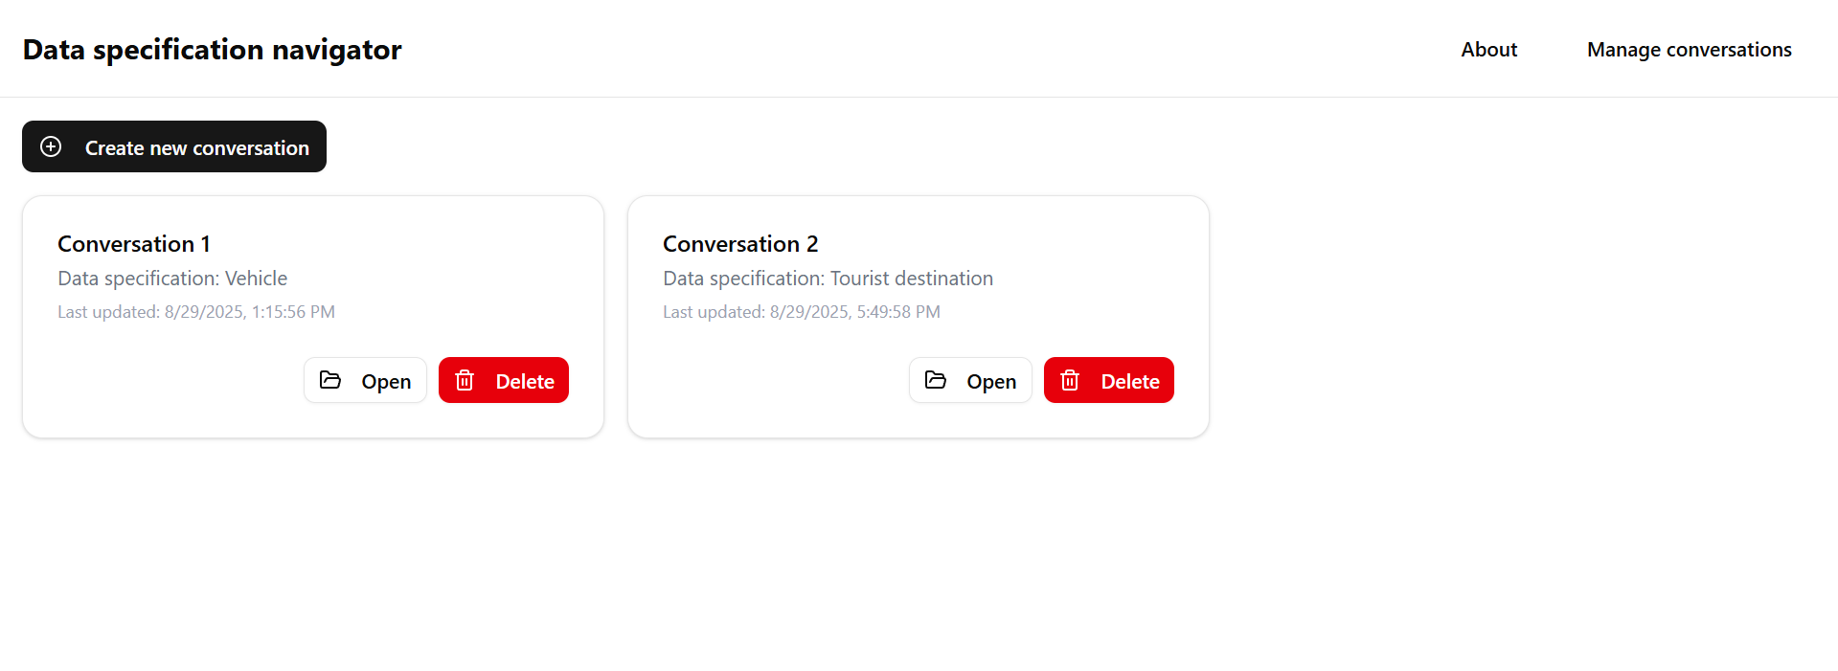

#### Core functionalities

**Display all conversations:** The view retrieves a list of all existing conversations from the backend and displays them in a grid of interactive cards. Each card shows the conversation’s **title**, the name of the **data specification** it’s based on, and the **last updated** timestamp. If there are not yet any conversations, the view provides the user with a short instruction on how to create a new conversation.

**Create a new conversation:** Users can create a new conversation in one of two ways:

1. **Manual creation:** By clicking the "Create new conversation" button, a dialog appears that prompts the user to manually enter the Dataspecer package IRI and a title for the new conversation.
2. **Browser redirect:** Conversation creation can also be initiated by a browser redirect from the Dataspecer tool. It detects specific URL parameters (uuid and packageName) to automatically open a new conversation dialog with the Dataspecer package information pre-filled. This feature was implemented to streamline the user experience when navigating directly from the Dataspecer tool.

**Open a conversation:** Each conversation card features an "Open" button that navigates the user to the dedicated Conversation View.

**Delete a donversation:** Users can permanently delete a conversation by clicking the "Delete" button on its card, which will prompt a confirmation dialog to prevent accidental deletion.

### Conversation view

This view is the primary interface for users to interact with the chatbot, emulating the familiar conversational flow of mainstream LLM services (see Figure 2).

Figure 2: Conversation welcome message

#### Core functionalities

**Conversation history:** The view fetches and renders all messages of the given conversation in chronological order.

**User input and submission:** The user can type their natural language query into an input field at the bottom of the screen. Upon submission, the UI immediately updates with the user’s message and it to the backend via a RESTful API call.

**Data specification navigation:** The UI provides two key features to help users navigate the data specification (see Figure 3).

* 1. **Mapped item highlighting:** The backend identifies and highlights words in the user’s message that refer to data specification items. The user’s message with highlighted words is displayed above the input text field. The UI renders these words as clickable links, and a pop-up dialog provides a summary of the corresponding item.
  2. **Query refinement via suggestions:** Each chatbot reply may contain suggested items from the data specification. Clicking on a suggestion opens a dialog with a detailed summary of the item, allowing the user to understand its purpose and relevance. Users can select one or more suggested items from the chatbot’s most recent reply to expand their query.

**Display a suggested message:** Once the user has confirmed selected suggestions, a suggested message is generated by the backend, and the view will display it above the input field. This verbalization combines the user’s message with the selected suggestions, allowing them to preview the expanded query before submission.

Figure 3: Words highlighting and suggestions

### Example workflow

This section provides an example that will present all the important elements of the UI.

The user navigates to the main page of the Data specification navigator, which is by default the conversation management view (see Figure 4).

Figure 4: Conversation management without any conversations created

The user follows the instructions and creates a new Dataspecer package. The user then copies the package IRI (see Figure 5).

Figure 5: Dataspecer package UI

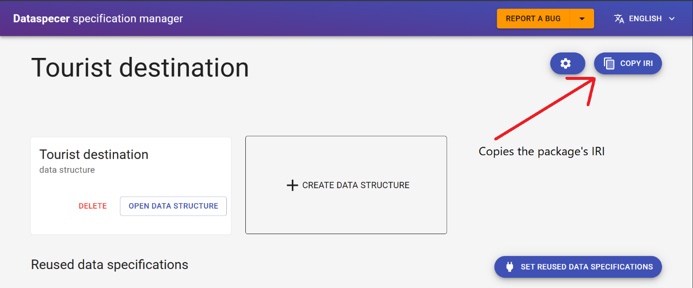

The user returns to the Data specification navigator, clicks on the “Create new conversation” and a form appears. The user fills in the necessary information (see Figure 6).

Figure 6: Conversation creation form

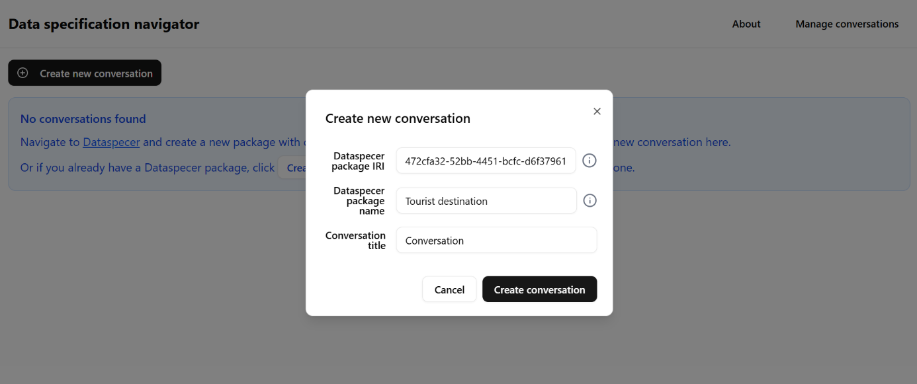

The user opens the newly created conversation and sees the welcome message (see Figure 2).

The user types their first message and sends it (see Figure 7).

Figure 7: Waiting for a chatbot reply

The chatbot sends an answer back. The right-side panel is updated with mapped items from the data specification. The reply from the chatbot is long so it is shown in two parts (see Figure 8 and Figure 9).

Figure 8: Chatbot reply - SPARQL query

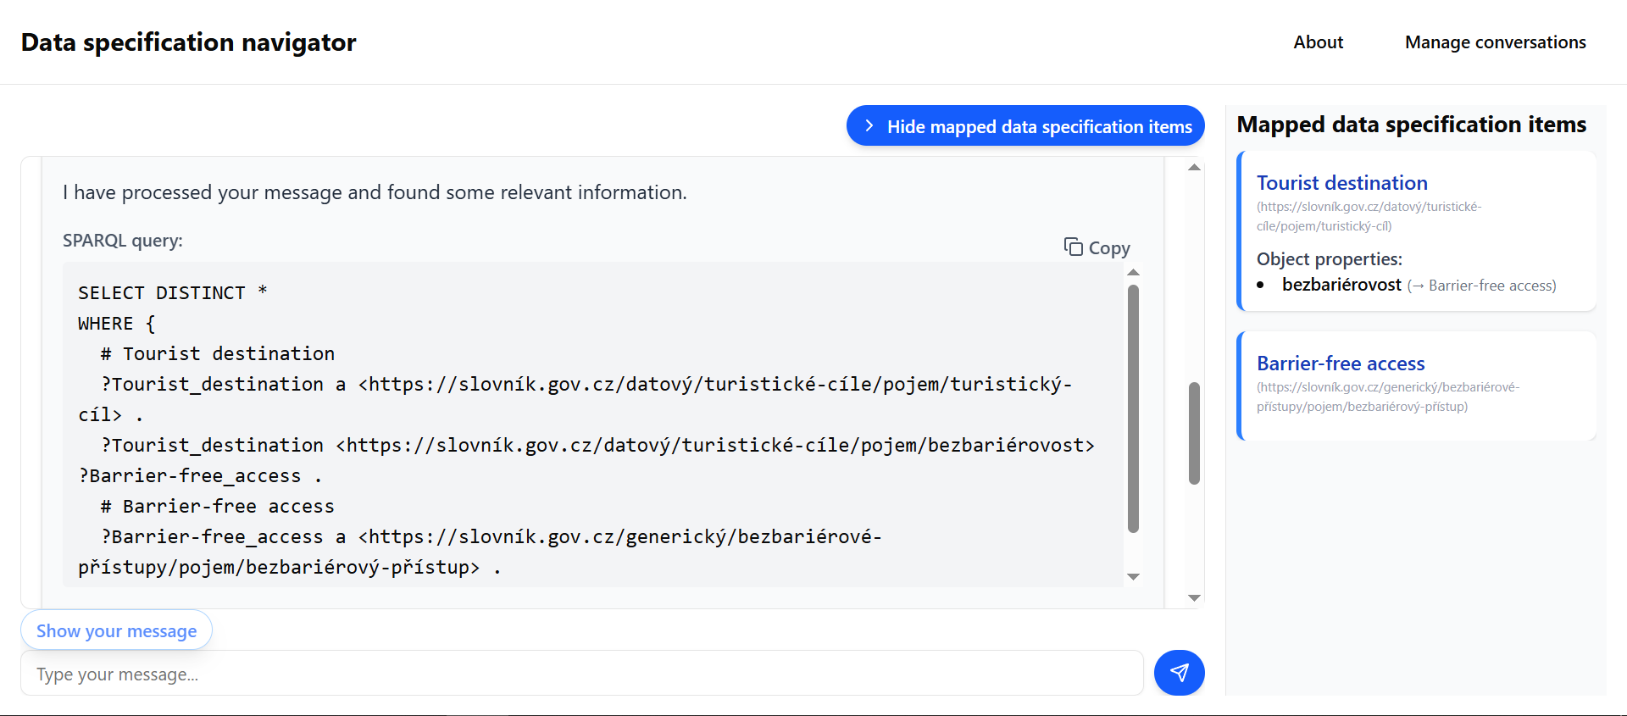

Figure 9: Chatbot reply - suggestions

The toggle “Show your message” shows the user message with the highlighted parts corresponding to the mapped items (see Figure 3).

The user selects some suggested items. The UI shows the button “Add all selected items to my message” on top of the chat (see Figure 10).

The user clicks the button to add all items which prompts the UI to retrieve the suggested message from the backend (see Figure 11).

The UI displays the received suggested message (see Figure 12).

Figure 10: User chooses suggestions

Figure 11: Waiting for a suggested message

Figure 12: Suggested message displayed

The user sends the suggested message as is. Alternatively, the user can modify the message before sending it.

The chatbot replies with the new answer (see Figure 13). Notice that the right-side panel is again updated with newly mapped items.

Figure 13: User sends suggested message and receives a reply

The conversation flow can continue in this manner until the user is satisfied.

At any point during the conversation, the user may click on a highlighted word in their current message to see a summary for that item. Or they may click on a suggested item to see a summary and a reason for the suggestion (see Figure 14 and Figure 15).

Figure 14: Summary of a mapped item

Figure 15: Summary of a suggested item

## Frontend implementation details

The frontend was developed using Vite, React and Typescript. This combination was chosen to provide a modern, efficient, and type-safe development environment. React helps provide a component-based user interface, which allows for a modular and reusable codebase. The use of **TypeScript** provided static typing, which reduces runtime errors and improves code maintainability, especially when handling complex data structures returned from the backend API. **Vite** was utilized as the build tool for its *Hot Module Replacement*during development and its optimized production builds.

### Conversation management view

This view is implemented as a React component and it interacts with the backend using RESTful API calls.

**Conversation deletion**

Upon confirming the delete action, the application performs an optimistic update, immediately removing the card from the UI and then sending a DELETE request to the backend. If the DELETE request fails, the UI will display an error and fetch all conversations again to display them to the user.

**Conversation creation by redirect**

The functionality for redirecting from Dataspecer directly to the conversation creation dialog is currently not live. It is implemented in a forked Dataspecer repository <https://github.com/Kwantigon/dataspecer/>.

### Conversation view

This view is a React component with many states, which utilizes the useState function from React.

**API calls for new user messages**

When the user sends a message, the frontend initiates a sequence of three API calls to the backend.

* It first sends a POST request to log the user’s message
* Followed by a GET request to retrieve the system’s reply.
* Finally, it makes a third GET request to retrieve the mapped data specification items to display in the right-side panel.

**Message rendering**

The view renders three distinct message types: welcome, user, and reply messages. The rendering logic for all messages is encapsulated in a separate `MessagesList` React component. This decoupling ensures the code is extensible and easy to maintain, which proved valuable during development as the message structure evolved.

**User message highlighting**

To show the interactive user message with highlighted words, there is a separate function named renderMessageWithMappedItems, which takes an array of MappedItem objects, which include the indices for the words in the user message that should be highlighted. The method renders these words as a clickable button, which upon clicking, will display a summary of the item.

## Backend

The backend is a monolithic application written in C# using the Minimal API framework. While deployed as a single unit, the system is designed with a layered and highly modular architecture to ensure it is extensible and easy to maintain.

The backend is logically divided into three layers:

1. **Business core layer:** This is the heart of the application, containing all the core business logic. It orchestrates the flow of data, handles conversation state, and processes user requests by interacting with the connectors.
2. **Connectors layer:** This layer is a set of interfaces that abstract communication with external systems. This design ensures that the business core is not directly dependent on any specific external service.
3. **External systems layer:** These are the third-party services that the application depends on, such as various Large Language Models (LLMs) and the Dataspecer tool.

### Connectors

This layer defines two main interfaces: ILlmConnector and IDataspecerConnector. This design allows for different implementations to be swapped in without affecting the core business logic.

#### Dataspecer connector

The sole purpose of this connector is to retrieve the data specification files (DSV and OWL) from Dataspecer. It is responsible for fetching these files and returning their contents to the business core layer.

#### LLM connector

To demonstrate the system’s independence from any specific LLM, I have created two separate implementations: OllamaConnector and GeminiConnector. Each connector is responsible for a specific LLM and its unique requirements, including prompting and response processing.

#### LLM interaction

The system’s interaction with the LLMs is handled through a pair of dedicated components for each connector:

* Prompt constructor (ILlmPromptConstructor): This component transforms the input from the business core into a format optimized for its specific LLM. For example, the LlamaPromptConstructor provides a relevant subset of the data specification to the smaller llama3.3:70b, whereas the GeminiPromptConstructor feeds the entire OWL content of the data specification into its prompt template.
* Response Processor (ILlmResponseProcessor): This component receives the raw output from the LLM, which is typically in JSON format as requested in prompt templates, and converts it into the data structures that the business core layer works with. This ensures the core logic can process the LLM’s response consistently, regardless of which LLM was used.

### Business core layer

This layer is the heart of the backend, containing the core business logic. It is composed of three main services: a Data Specification Service, a Conversation Service, and a SPARQL Translation Service. Each service has a single, well-defined responsibility, which ensures a strong separation of concerns.

To make the system easier to maintain and debug, only the Data Specification Service and the Conversation Service have the right to store data to the database, ensuring a single point of data entry for persistence. An exception to this rule is the response processor class, which is allowed to fill in the summary for each data specification item whenever the LLM returns it. All other classes can still access the database for reading but must not write to it.

#### Data specification service

This service is responsible for retrieving and processing the data specification that the user wants to work with. It utilizes the Dataspecer connector to retrieve the DSV or OWL files and then extracts the data specification items from those files for use by the other services.

#### Conversation service

This is the most complex service, managing all aspects of the conversation. Its responsibilities include:

* **Conversation creation:** It creates a new conversation and generates an initial welcome message. This message contains a summary of the data specification and suggests possible starting points for the user.
* **Message processing:** When a user sends a new message, this service adds it to the conversation. It then processes the message by mapping the user’s natural language to the data specification items and generating suggestions for the user.
* **Reply generation:** The service generates the chatbot’s reply message, which includes the mapped items, suggestions, and the SPARQL query.
* **Message preview:** It can verbalize a "suggested message" for the user after they have selected suggested items, providing them with a clear, natural-language preview of the expanded query.

The data specification items successfully mapped during the conversation are stored in the conversation itself, forming a mapped substructure. This substructure represents the relevant subset of the full data specification and serves as the primary input for the SPARQL translation service.

#### SPARQL translation service

This service is solely responsible for generating a SPARQL query from the mapped substructure. This translation happens only once, when the chatbot’s reply message is being generated, ensuring that the heavy lifting of query generation is done efficiently on the backend before the reply is sent to the frontend.

### Controllers

The final component of the backend are the controllers: IDataSpecificationController and IConversationController. These controllers serve as the entry point for all incoming requests from the frontend and act as an interface to the business core.

Their responsibilities include:

* **Request validation:** They validate incoming data from the frontend, ensuring the data is in the correct format and that any referenced resources, such as conversations or data specifications, exist in the database.
* **Service orchestration:** They orchestrate the business logic by calling the appropriate methods on the service layer. For example, the `ProcessIncomingMessage` method in the IConversationController would coordinate calls to the `AddUserMessageAsync` and `GenerateReplyMessageAsync` methods on the IConversationService.
* **Response adaptation:** They adapt the results from the business services into the specific data format the frontend expects, ensuring a clear and consistent API contract.

## Backend implementation details

This chapter provides a deeper dive into the technical implementation of the backend modules.

### Connectors

This section discusses the technical details of the various connectors.

#### Dataspecer connector

The DataspecerConnector is the concrete implementation of the IDataspecerConnector interface. It uses the dotnet HttpClient to download the Dataspecer package specification from a configurable endpoint. It then retrieves either the en/dsv.ttl or en/model.owl.ttl file, depending on the method called. The default endpoint is https://tool.dataspecer.com/api/experimental/output.zip?iri=, but this can be changed by modifying the Env:Dataspecer:Endpoints:DownloadDocumentation environment variable. This configurability is particularly useful for local Dataspecer deployments.

#### LLM connectors

Two distinct LLM connectors were implemented.

OllamaConnector: This connector uses the OllamaSharp library to interact with a locally deployed LLM instance. By default, it sends prompts to llama3.3:70b at localhost:11434. The connector, as well as its associated prompt constructor and response processor (LlamaPromptConstructor and LlamaResponseProcessor), are specifically tuned for this model. While the model can be changed via the Env:Llm:Ollama:Model environment variable, a different model may not adhere to the expected output format, causing the response processor to fail (e.g., Deepseek’s <thinking> block is not handled).

GeminiConnector: This connector is implemented using the Google_GenerativeAI library and requires a valid API key from the ./Secrets/Gemini_api-key.txt file. For the current build, this connector has been commented out of the dependency injection configuration, as the system is only set up to use one LLM at a time. The code is structured to allow easy swapping between connectors but lacks a mechanism to support multiple LLMs simultaneously, a decision made to prioritize development on core features.

#### LLM prompt templates

The system uses six distinct prompt templates, stored as plain text files, to handle different operations. They are called in the following order:

* welcome_message_data_specification_summary.txt: Generate a summary about the data specification and suggest some starting points for the user.
* map_to_data_specification.txt: Maps a user’s natural language message to the data specification to identify relevant items.
* get_suggested_items.txt: Suggests additional data specification items that the user might find useful.
* generate_suggested_message.txt: Verbalizes a "suggested message" by incorporating a user’s selected suggestions into their original message.
* map_to_substructure.txt: Maps the user’s confirmed suggested message to the conversation’s mapped substructure, which is used for highlighting on the frontend.
* summarize_data_specification_items.txt: Generates a short summary for mapped or suggested items before they are displayed to the user.

All templates are in Markdown format and follow a similar structure: they begin by assigning a role to the LLM, followed by a description of the inputs, the task, and the required output format.

#### Key prompting strategies for llama3.3:70b vs Gemini

The smaller size of llama3.3:70b required a different prompting strategy compared to larger models like Gemini.

* Data specification handling: Instead of providing the entire OWL file, the Llama prompts pass a flattened JSON list of relevant data specification items to reduce token size and improve performance. For some operations (e.g., generating a suggested message), the data specification is omitted entirely. For others, like suggesting items, a "local area" around the mapped substructure is provided to the model.
* Consistent data format: To reduce the cognitive load on the LLM, the input data and the requested output are both in a JSON format.
* Explicit output specification: While Gemini prompts list output fields in a list, Llama prompts use an example JSON object or array to explicitly define the output shape.
* Rule reinforcement: Smaller models are more likely to "forget" strict rules in long prompts. Llama prompts repeat key rules (e.g., returning only a raw JSON object) multiple times to ensure the model adheres to the format.

#### Response processing

Assuming the LLM provides a response in the expected format, the response processor, implemented using dotnet JsonSerializer, parses the JSON into a temporary object. It then validates the data against the database and creates the necessary classes for the business core layer. A common issue is that LLMs often wrap JSON output in backticks (e.g., ```json [...]```), so the response processor is designed to automatically detect and remove these characters.

### Business core layer

This section discusses the technical details of each module in the business core layer, including data models and service-level implementations.

#### Data model

The backend data model is designed to represent and manage the entire conversational flow and its associated data. It is composed of a core set of classes that store conversational history, data specification items, and the relationships between them.

**Data specification items**

The system models three types of data specification items, which correspond to OWL ontology elements: ClassItem, ObjectPropertyItem, and DatatypePropertyItem. These classes store the following properties for each item:

* Iri: A unique identifier for the item.
* Label: A human-readable name for display in the frontend.
* Type: An enumeration (Class, ObjectProperty, or DatatypeProperty) to easily distinguish the item’s role.
* Context properties: The OWL annotation and rdfs comment are stored to provide valuable context for the LLM during prompt construction

**Messages**

The system defines three types of messages: WelcomeMessage, UserMessage, and ReplyMessage. Each message type shares a core set of properties:

* TextContent: The textual content of the message.
* Conversation: A link to the conversation the message belongs to.
* Timestamp: The time the message was created.
* Sender: An enum value to indicate the source of the message (either system or user).

Specific message types:

* **WelcomeMessage:** Contains a summary of the data specification and initial suggestions to guide the user’s first message. There is only one welcome message per conversation.
* **UserMessage:** Represents a message from the user. It contains a reference to its corresponding ReplyMessage.
* **ReplyMessage:** Generated by the system in response to a UserMessage. It contains the final SPARQL query that was translated from the mapped substructure.

**Mapping and suggestions**

Two helper classes are used to store information about mapped and suggested data specification items, which are not stored directly on the message classes.

* **DataSpecificationItemMapping:** Links a UserMessage to a mapped data specification item. It also stores the MappedWords, which are the exact words from the user’s message that the LLM identified as corresponding to this item, enabling highlighting in the frontend.
* **DataSpecificationItemSuggestion:** Links a UserMessage to a suggested data specification item. It also stores a ReasonForSuggestion, which is the LLM-generated explanation for why the item was suggested. This class is designed to recommend properties, not classes, as a class without a connecting property is not a meaningful suggestion in this context.

**Conversation management**

**Conversation:** The core class that holds and manages all messages. It ensures messages are stored in chronological order. It also contains the mapped substructure (DataSpecificationSubstructure), which is built during the conversation, a list of UserSelection, and an optional SuggestedMessage string.

**DataSpecificationSubstructure:** Represents the subset of the data specification that has been mapped during the conversation. It is a list of classes, with their associated properties and their domains and ranges. It also stores the user's choices, such as whether a property is optional or a filter expression for a datatype property. All fields in the classes and properties inside the substructure are stored using simple data types – string and boolean. This was a deliberate choice to make the substructure easily serializable to JSON. The serialized JSON string is stored in the database and sent to the frontend whenever requested so that it can be displayed to the user.

**UserSelection:** A helper class that captures user-specific choices for a suggested item, such as marking a property as optional or providing a filter expression for a datatype property.

**DataSpecification:** A helper class that stores the original OWL content, name, and the UUID of the Dataspecer package. It logically groups the data specification items together but does not play an active role in the conversation flow.

The **SuggestedMessage** in the conversation is an optional string that holds a verbalized suggested message. This property is a core part of the mechanism used to distinguish between a new mapping to the full data specification and a mapping to the already established substructure. This functionality is further detailed in the section about the Conversation service.

To do: add images, class diagram, database schema.

#### Data specification service

After retrieving the data specification in DSV format, this service uses the dotnetRDF library to convert the DSV syntax into OWL syntax. The conversion algorithm parses each DSV triple and checks the triple’s predicate. If the predicate corresponds to an OWL predicate, the algorithm generates a new triple with the corresponding OWL predicate while preserving the original triple’s subject and object.

As a fallback, if the Dataspecer connector fails to return the DSV file, this service will ask for the OWL file. If both fail, the service returns null, indicating an error. The preference for the DSV file is due to it containing more information, such as property cardinality, and because some Dataspecer packages may only provide a DSV file.

After a successful retrieval of the OWL representation, this service once again uses the dotnetRDF library to parse the OWL file triple by triple to extract all information on each data specification item. These items are then persisted in the database.

#### Conversation service

This service is responsible for all conversation-related operations.

It is responsible for creating a new conversation and generating a welcome message by calling the LLM to get a summary and initial suggestions for the user.

When the user selects one or more suggested items, this service stores the user's choices and generates a SuggestedMessage for the user. This message is stored in the conversation, which is critical for processing the next user input.

The most complex operation is adding a new user message. The system's logic follows two main scenarios:

**New conversation or unmatched suggested message**

* If the user message does not match the stored SuggestedMessage or if a SuggestedMessage does not exist (e.g., this is the first user message), the service calls the LLM to map the message to items from the full data specification.
* If at least one item is successfully mapped, it's added to the mapped substructure (DataSpecificationSubstructure in the conversation). When adding properties, their corresponding domain and range classes are also added to prevent "dangling references."
* The service then calls the LLM again to get suggestions based on the mapped substructure and proceeds to generate a reply. If no items are mapped, the service generates a negative response.

**Confirmed SuggestedMessage:**

* If the incoming message is identical to the SuggestedMessage stored in the conversation, the service concludes that the user has confirmed their previous selections without modification.
* It then adds the user's selections to the mapped substructure.
* The service calls the LLM to map the newly expanded substructure to the words in the user's message, which provides the MappedWords for highlighting on the frontend.
* Finally, it generates new suggestions and proceeds with generating a reply.

The SPARQL query in the reply is generated by calling the SparqlTranslationService with the mapped substructure from the conversation.

When asking for mappings, the LLM might fail to return ‘MappedWords’ or it might map the same words to multiple items. If ‘MappedWords’ is empty, we store those mappings without any modifications. In the latter case where some mapped words might overlap, we keep all the mappings but reset the duplicate ‘MappedWords’ to an empty string.

#### Sparql translation service

This service receives a DataSpecificationSubstructure object as input and outputs a SPARQL query as a string. To perform its task, it first converts the substructure into a directed graph. This graph representation makes it easier to traverse the relationships between classes and properties.

The service uses a helper QueryGraph class, where each class in the substructure is a node, and each property is an edge. ObjectProperty edges connect class nodes, while DatatypeProperty edges connect a class node to a leaf node representing a simple data type. Filter expressions and optional flags from the user selections are attached to the corresponding nodes and edges in the graph. The service then traverses this graph to construct the final SPARQL query.

### Controllers

There are two main controller interfaces: IDataSpecificationController and IConversationController. These controllers serve as the public API endpoints, handling communication with the frontend and orchestrating calls to the business services. They utilize a set of DTO classes to shape the data for network communication.

* IDataSpecificationController: This controller is implemented but remains unused in the current version. It is a provision for future work to support data specification management, such as allowing users to upload and manage data specifications within the system, separate from a conversation.
* ConversationController: This is the core controller that handles all communication with the chatbot frontend. It is responsible for deserializing incoming request payloads into the appropriate DTOs, validating them, and then using the results from the ConversationService and database to build and serialize response DTOs for the frontend.

A key part of the ConversationController’s job is building the ReplyMessageDTO. In addition to the standard message properties, this DTO contains:

* The generated SPARQL query string.
* A list of mapped data specification items with their summaries and MappedWords for highlighting.
* A list of suggested data specification items, each with a summary and a ReasonForSuggestion.

The controller performs two key transformations to prepare this data for the frontend:

* 1. **Highlighting calculation:** For each mapped item, the controller calculates the exact character positions of the MappedWords within the user's message. This is what the frontend uses to highlight the relevant text. If a mapped item has no MappedWords, it is still returned to be displayed in a separate section on the frontend.
  2. **Suggestion grouping:** The controller uses a helper class called SuggestionsTransformer to group the suggestions. It groups them by the class that the suggestion expands (typically, the suggested property's domain). This allows the frontend to display the suggestions in a logical, structured way, which is crucial for a positive user experience.

### Notable API endpoints

The project directory contains a swagger.yml file, which contains the OpenAPI documentation for the full set of available endpoints. This chapter gives an overview of the most important endpoints that the frontend uses to communicate with the backend.

GET /conversations

* Returns all the conversations in the database.
* The conversations only contain basic information: id, title, data specification name and time of the last update.
* The frontend calls this endpoint in the conversation management view to display available conversations to the user.

DELETE /conversations/{conversationId}

* Deletes the specified conversation and all associated resources.
* The frontend calls this endpoint in the conversation management view when the user confirms deletion of a conversation.

GET /conversations/{conversationId}/messages

* Returns all messages in the conversation.
* The frontend calls this endpoint when the user opens up a conversation.

POST /conversations/{conversationId}/messages

* Adds a message to the conversation.
* Returns the newly added user message which also contains the location of the reply message that was generated for it.
* The frontend calls this endpoint when the user sends a message.

GET /conversations/{conversationId}/messages/{messageId}

* Returns the specified message in the conversation.
* The frontend only calls this endpoint to retrieve the reply message from the previous POST /conversations/{conversationId}/messages call.

GET /conversations/{conversationId}/data-specification-substructure

* Returns the conversation’s DataSpecificationSubstructure object (which are the mapped items).
* The frontend calls this endpoint to display the mapped items to the user.

# Deployment

The application is deployed as a single Docker container that contains both the backend service and the frontend. The following sections outline the prerequisites and steps required for a successful deployment.

## Prerequisites

To deploy and run the application, you must have the following installed:

* Docker: For containerizing the application.
* Docker Compose: To build and run the multi-container application with a single command.
* LLM Instance: The application requires a running Large Language Model (LLM) to function. By default, it is configured to connect to an Ollama instance.

If you don’t have a local Ollama instance or would prefer using the Gemini LLM, you must check out the gemini branch in the Git repository <https://github.com/Kwantigon/DataSpecificationNavigator/>. This branch requires a valid Gemini API key, which should be saved in a file named Gemini_api_key.txt within the following directory: DataSpecificationNavigator/backend/DataSpecificationNavigatorBackend/Secrets.

## Installation

The installation instructions can be found in the README.md file in the project’s repository (link given above). For completeness, they are replicated here.

1. **Clone the repository**

*git clone https://github.com/Kwantigon/DataSpecificationNavigator*

*cd DataSpecificationNavigator*

2. **Change the default Ollama configuration**

By default, the backend will try to connect to Ollama using the following values:

- Uri: http://host.docker.internal:11434

- Model: llama3.3:70b

This default setting assumes that Ollama is listening on the host machine at port 11434. If Ollama is listening on a different address you must set its URI in the .env file. To change default settings, do the following:

*cp .env.example .env*

Then replace the dummy values with your own values.

3. **Build the docker images**

*docker-compose build*

**IMPORTANT:**

The docker-compose.yml specifies mapping of `host.docker.internal` to `host-gateway`. On Linux it means `host.docker.internal` address is likely mapped to 172.17.0.1

If Ollama is listening on 127.0.0.1:11434, then the backend *WILL NOT* be able to connect to it. Make sure Ollama listens on the correct address.

**SSH tunneling to Ollama**

If the LLM is served by Ollama on a remote server, then you must make sure there is an SSH tunnel to the remote server. The following command creates an SSH tunnel that listens on all interfaces.

*ssh -f -N -L 0.0.0.0:11434:localhost:11434 user@remote-server*

This is important because if the SSH tunnel is from 127.0.0.1:11434 to the remote server, then the backend cannot reach it from inside the container.

## Running the app

After building the images, run both the frontend and the backend.

*docker-compose up*

By default, the frontend is served at **http://localhost:8080**.

The backend is running at **http://localhost:8080/backend-api**.

You can try sending a GET requrest to **http://localhost:8080/backend-api/hello** to check that the backend is running.

**Changing the base URL and port**

You can change the base URL by setting the `BASE_URL` value in the .env file. For example, if you want the app to run at **http://localhost:8080/my/custom/path**, set “BASE_URL=/my/custom/path” in the .env file.

Similarly, you can change the default port for the app by setting the APP_PORT value in the .env file.